**Candy Cane Grams**

Help support your Century Cheer and Spirit Squads! Century Cheerleaders have candy grams for sale for $1.00. Candy Cane Grams will be sold during the 3rd/4th and 5th/6th lunch hour. Or you may purchase a candy gram by filling out the information below and sending it to the **office** by December 17th. They will be delivered to the classrooms on December 20th t.

Please enclose cash with your order or checks payable to Clovis USD. Thank you!



Happy Holidays!

To: ____________________________

Room/Teacher:_____________________

From:___________________________

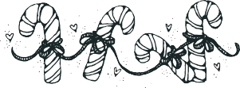

Happy Holidays!

To: ____________________________

Room/Teacher:_____________________

From:___________________________